EMBRACING INTERFAITH

EMBRACING INTERFAITH
AGENDA

1. INTRODUCTON

2. WHAT IS INTERFAITH?

3. FINDING COMMON GROUND

4. INTERFAITH CO-OPERATION

5. PLANNING AN INTERFAITH EVENT

6. TAKEAWAYS AND CLOSING

LOVINGKINDNESS MEDITATION

- The following lovingkindness meditation wills compassion for all beings, and is relevant for people of any faith tradition or none. It starts by willing compassion for ourselves, before expanding to include those we love unconditionally, someone who is neutral to us, someone who is challenging, and finally, all people and all beings.

- Say the prayer first for yourself:

May I know my wholeness.
May I dwell in the heart.
May I be free from suffering.
May I be healed.
May I be happy.
May I be at peace.

- If you prefer, you may like instead to say “Dear God, Let me know my wholeness, let me dwell in my heart, … etc.”

- Next, repeat the prayer for someone you love, such as a family member or close friend:

May [person’s name] know their wholeness.
May they dwell in the heart.
May they be free from suffering.
May they be healed.
May they be happy.
May they be at peace.

- Repeat the prayer, this time for someone you don’t know well.

- Next, say the prayer for someone who has challenged you, or who you’ve at times find hard to love.

- Finally, say the prayer for all people and all beings (human and animal, extending to all plants, trees and mineral life too if you wish):

May all beings know their wholeness.
May all beings dwell in the heart.
May all beings be free from suffering.
May all beings be healed.
May all beings be happy.
May all beings be at peace.

WHAT IS INTERFAITH? DEFINITIONS

- Interfaith recognizes that there are many diverse ways for individuals to express their spiritual selves and to connect with what is sacred.

- Sacred. Something that is sacred might be something that is related to, or an expression of, God. This includes objects and symbolism used in religious practices; buildings and spaces that are designated as places for worship, contemplation, and prayer; and scriptures, poems, and songs that inspire wonder and awe.

- God. In an interfaith context ‘God’ might be taken to be ‘The source of all life and supernatural intelligence that creates, destroys, and sustains everything that we experience, as well as much more that we do not see and can never comprehend.’ However, because God’s power, essence and being is far greater than anything we can ever conceive, acting beyond levels of consciousness and physical dimensions that are familiar to us, we can never adequately describe Who or What God is. Some traditions may talk in terms of ‘Source,’ ‘Spirit,’ ‘Ground of Being,’ ‘All That Is,’ or in some other way to knowing God as ‘Father,’ as is the case with Judaism and Christianity.

- Religion. Nineteenth Century American psychologist William James offered one definition of what is meant by ‘religion’ in his book Varieties of Religious Experience, talking of religion as the “feelings, acts and experiences of individual men in their solitude so far as they apprehend themselves to stand in relation to whatever they may consider the divine.”

- Spirituality. Common key themes that tend to occupy the mind of someone who describes themselves as being ‘spiritual’ or ‘religious’ include:

  - Love, with its focus on ‘the promise of belonging’,
  - Death, which brings home an ‘awareness of being’,
  - Self, emphasizing ‘the path of becoming’, and
  - Soul, opening us to a ‘sense of beyondness.’ The soul is difficult to define, but is widely seen as the unseen, non-physical but essential part of a human being that survives death.

- Interfaith puts emphasis on the idea of individuals sharing their faiths, rather than attempting to align with or compromise their distinctive, organized or institutionalised beliefs. A readiness to tolerate and deeply respect the worldviews of others also applies within a single faith tradition (e.g. between Roman Catholics, Baptists and Evangelicals among Christians, or Orthodox, Reform and Hasidic denominations among Jews).

- Interfaith activities include appreciating the value of dialogue between the followers and leaders of different faith traditions, recognizing the commonality in the central teaching of most faiths, and encouraging tolerance of peoples who hold different worldviews. This might include offering platforms for representatives of faiths other than our own to speak at meetings, sharing in some form of worship, or simply fostering friendship between communities.

- At an individual level, the teachings our own faith might also sometimes be illuminated by similar teachings found in other traditions (e.g. in the way that parables in The Bible teach what the Kingdom of God is like). We might also find spiritual practices that share common ground (e.g. Centering Prayer is very similar to mantra-based meditations practiced by Hindus, Buddhists and others).

WHAT OTHERS BELIEVE

The following offers a very broad-brush outline of the general thinking of several common faith traditions. There may be significant differences of belief within each tradition, as well as differences in organization (e.g. the way churches are structured), dogma, worship practices, and so on. Some ‘religions’ are in fact a complex of beliefs, more umbrella terms than a specific faith tradition. Hinduism, for example, may be described as either a religious tradition, a set of teachings and practices, a religious tradition, a way of life, or dharma—a religious and universal order by which followers live by.

- Judaism: Jewish people believe there's only one God who has established a covenant—or binding agreement—with His people. God communicates to believers through prophets and rewards good deeds while punishing evil. Most, but not all, Jews believe that their Messiah is yet to come.

- Christianity: Christians believe there’s one God Who created the Earth and Heavens. God expressed His love as The father (God Himself), through His son (Jesus Christ) and through The Holy Spirit. God sent His son Jesus, the Messiah, to save the world. He was crucified on the cross to offer forgiveness of sins and salvation for those who come to Him. Jesus was resurrected three days after his death and soon after ascended to Heaven. Christianity is practiced in many different ways, with Catholicism, Protestantism (including Anglican, Pentecostal, Baptist, Methodist, Quaker, and Episcopalian), Eastern Orthodox and evangelical denominations being most common. Christians believe that Jesus’ ministry is the fulfillment of prophesy revealed in The Old Testament. Most of the very first Christians were Jewish. The Holy Spirit is sent to guide all who accept Jesus Christ as their saviour.

- Islam: Muslims worship one, all-knowing God, Who in Arabic is known as Allah. Muslims aim to live a life of complete submission to Allah. They believe that nothing can happen without Allah's permission, but humans have free will. God revealed Himself to His people through the Prophet Muhammad in The Qur’an. Muslims share many beliefs held by Jews and Christians, considering Jesus as a prophet, and having similar reverence for the patriarchs of The Old Testament. The two main groups within Islam are Sunni and Shi’a, with Sunnis focusing on following the Prophet's example while Shi'a focus on the lineage of Muhammad's family. Sufis follow the mystic tradition of Islam.

- Adventism: Adventists believe that Christ will soon return in physical form to Earth and will then begin a kingdom lasting for 1,000 years. At His Second Coming, Christ will separate the saints from the wicked. Adventists draw on protestant beliefs, but particularly emphasise their understanding of the coming millennium, based on their interpretation of Revelation, the final book of The Bible.

- Jehovah’s Witness: Witnesses hold a number of traditional Christian views but also many that are unique to them. They do not believe there is a Trinity Godhead, believing that Jesus was created by God, but is not equal with Him. They use their own version of The Bible called the New World Translation, and claim that God—Jehovah—is the most high.

- Banyarwanda and Barundi: Traditionally the people of Banyarwanda and Barundi believed that there is one Almighty God and Creator, Imana, Who is ruler of all life and conqueror of death. Many today recognize the Christian God as being one and the same as Imana.

- Baha’i: Baha’is believe in the oneness of humanity and aim for the abolition of racial, class, and religious prejudices. Baha'u'llah, a prophet and the founder of the faith, called for racial unity, gender equality, universal education, and harmony of science and religion.

- Daoism or Taoism: Taoists believe that humans and animals should live in balance with the Tao, or the universe. They believe in spiritual immortality, where the spirit of the body joins the universe after death. Stemming from beliefs of ancient China, Taoists teach genuineness, longevity, health, immortality, vitality, wu wei (in natural, perfect balance with Tao), detachment, refinement spontaneity (going with the flow), transformation and unlimited potential.

- Buddhism: Buddhists believe that human life is one of suffering, and that meditation, spiritual and physical effort, right thinking and good behavior are the ways to achieve enlightenment, or nirvana. Life continues through many incarnations until we can detach ourselves from our ego’s yearnings, and finally find enlightenment. The way to live was revealed to The Buddha, Siddhārtha Gautama, a former prince who ran away from a life of luxury to seek the truth, achieving enlightenment after six years of searching while meditating under a Bodhi tree.

- Hinduism: Hindus believe in one God, Brahman, worshiping this one God who appears as many manifestations, deities or images ( Hindu deities include Krishna, Shiva, Rama and Durga). Hindus believe that life is a cycle of birth, death and rebirth, governed by karma (a complex belief in cause and effect of our thoughts and actions). Like Buddhists, Hindus believe that we ultimately reunite with God, coming to moksha (nirvana). Many Indian-originated traditions, including Buddhism and Jainism, have their roots in Hindu traditions. There are many similarities of belief in each faith.

- Sikhism: Sikhs believe that there is only one God, Who is accessible to everyone. Sikhs believe in meditating upon and being faithful to the Creator, practising truthful living, and being of service in their communities and to all people. They believe that we each live through a repeated cycle of birth, life, and rebirth, until finally coming to fully know and being reunited with God.

- Jainism: Jains believe that the path to enlightenment is through nonviolence and not harming living things (including plants and animals). They believe that the cycle of birth, death, and rebirth is determined by one's karma, and are guided by the 'Three Jewels' of right belief, right knowledge and right conduct.

- Pagan, Animism and Earth-based religions: Generally, followers of such traditions believe that nature is sacred and that the natural cycles of birth, growth and death in Nature have deep spiritual meaning. Animists believe that soul or spirit energizes all life. For most Earth-based religions, human beings are seen as part of Nature. Some see death as a transition within a continuing process of existence, and some may honour deities through rituals and ceremonies, especially marking the changing of the seasons and Nature’s cycles.

- ‘Spiritual but not religious’: not a faith tradition as such, but some claim to be spiritual without adhering to any faith tradition, or–in some cases–draw on the teachings of several faiths, perhaps with one being a main foundation. ‘Spirituality’ might be taken to mean having a feeling, sense or belief that there is something greater than ourselves that gives life purpose, not restricted to sensory experience, and that we are part of a greater whole that is cosmic or divine in nature.

- In Rwanda, according to the 2012 Census, of the total population:

  - 44 percent were Catholic; 38 percent Protestant (including Anglican, Pentecostal, Baptist, Methodist, Quaker, Episcopalian, and evangelical Christian churches); 12 percent Seventh-day Adventist; 2 percent Muslim; and 0.7 percent Jehovah’s Witnesses
  - < 1% combined are of other faiths, including Animists, Baha’is, The Church of Jesus Christ of Latter-day Saints, and a small Jewish community (mainly immigrant/ex-pats)
  - The Rwanda Muslim Community (RMC) stated Muslims could constitute as much as 12 to 15 percent of the population, mostly Sunni
  - There are no strong concentrations of religious groups living in particular areas, although a significant number of Muslims live in the Nyamirambo neighborhood of Kigali
  - Approximately 2.5 percent of the population hold no religious beliefs.

VARIETY IN CHRISTIAN PRACTICE

- Selected comparison of seven Christian denominations.

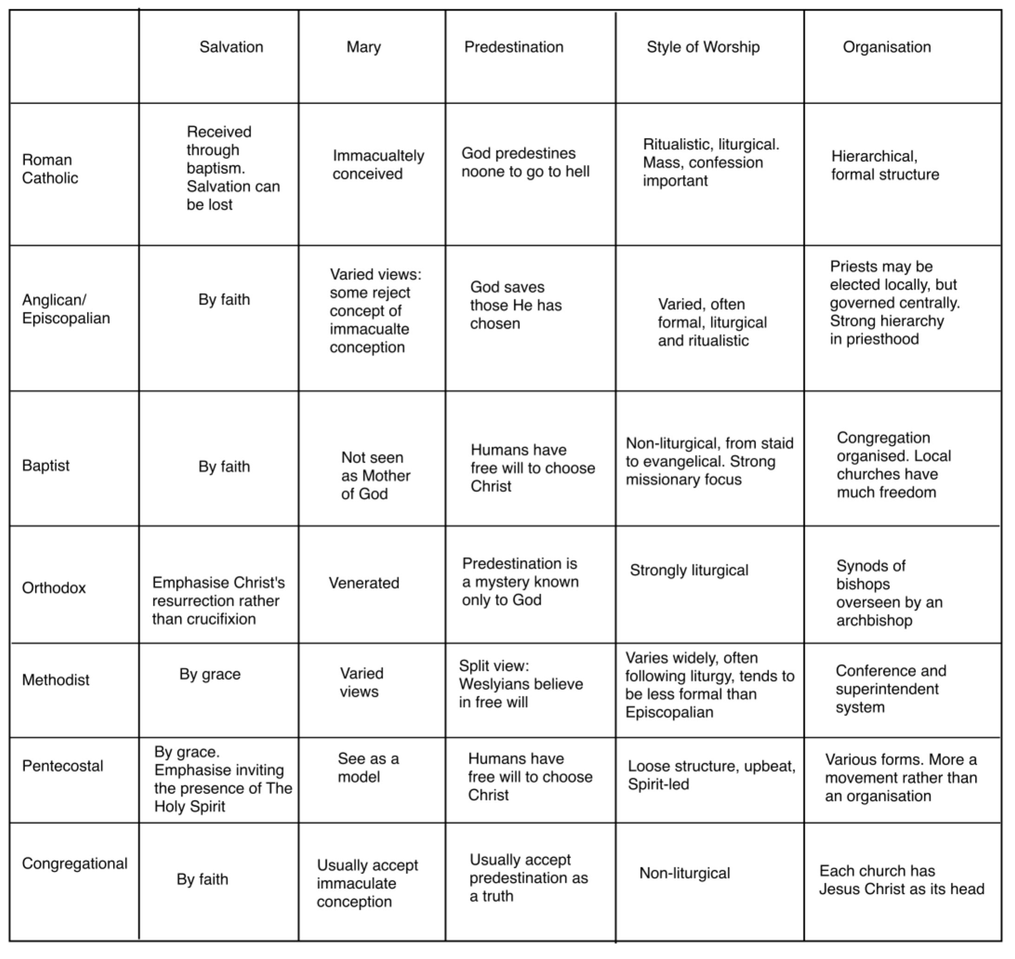

FAITH TRADITIONS
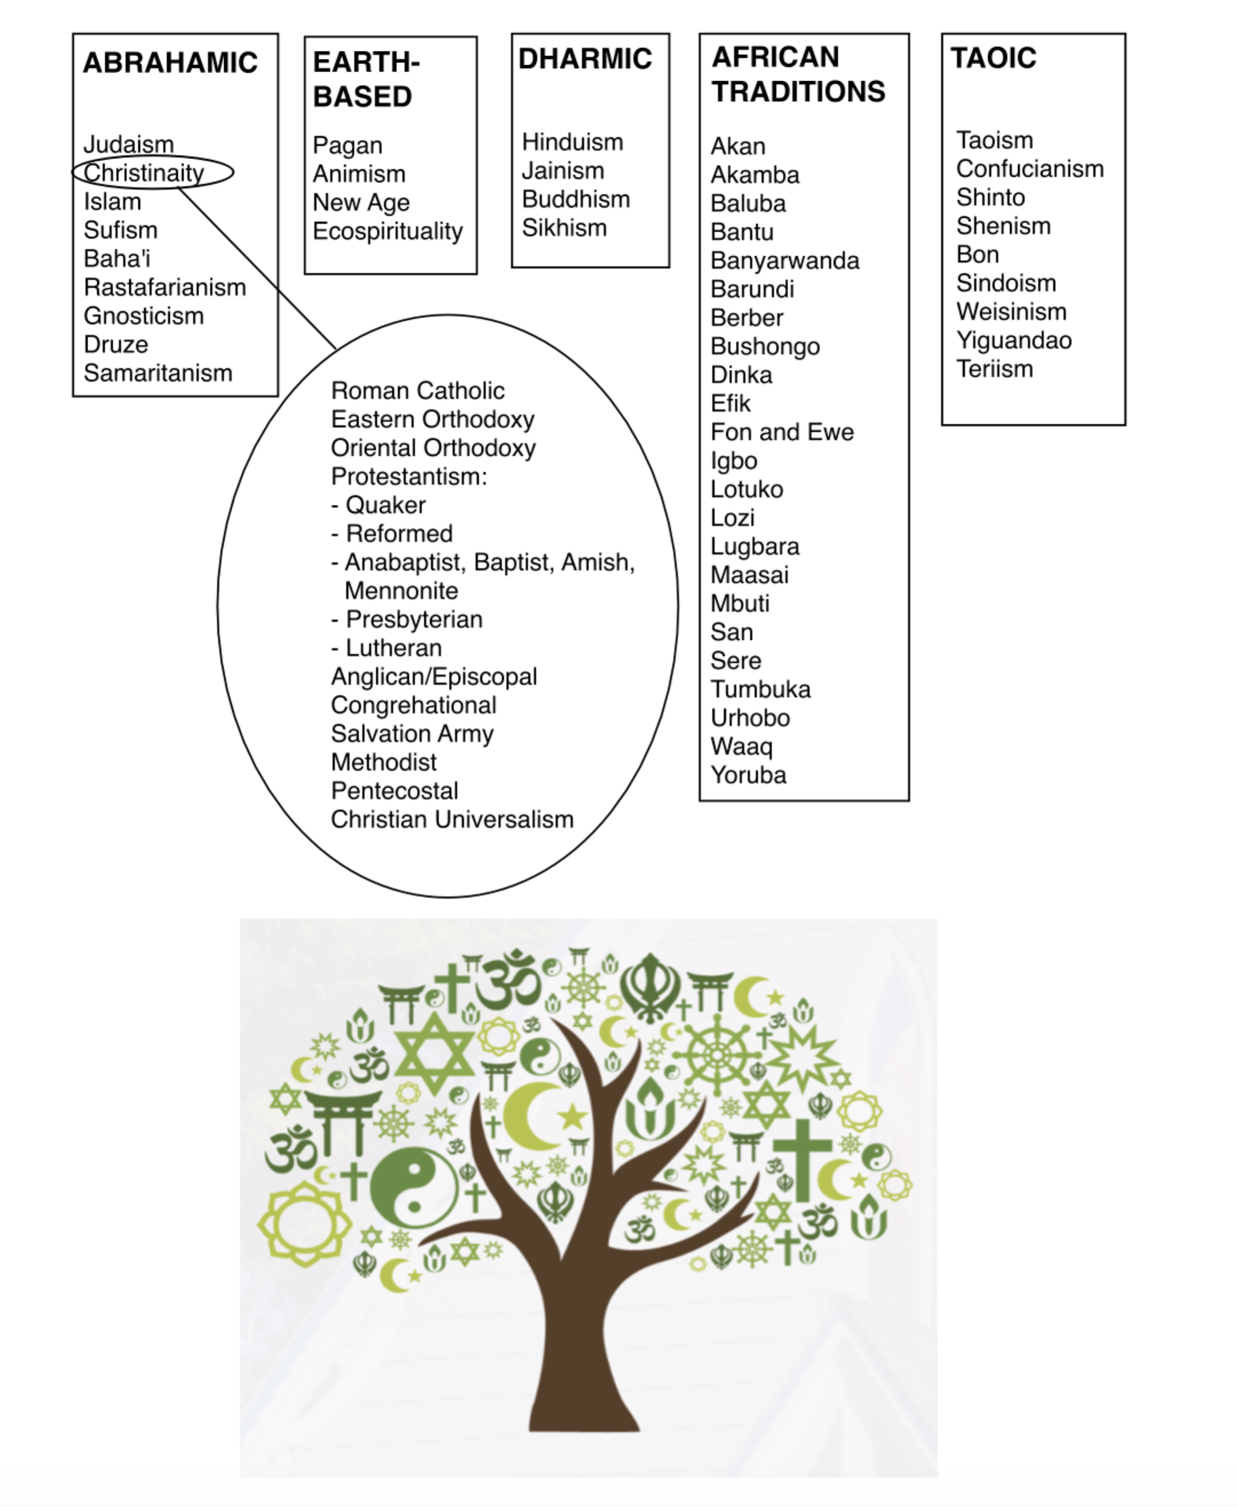

CHALLENGES AND RESOLUTIONS

CHALLENGES

How might talking with or working with individuals who don’t share your beliefs challenge you? How might you respond if you feel yourself being challenged?

RESOLUTIONS

As a result of this course, what do you resolve to do? List your commitments for yourself below.

FACILITATION

- Facilitation may apply to hosting an event, or assisting a process, training course, planning meeting, resolving differences, and more, where a group of people come together for a particular purpose, but not having a pre-defined agenda or way of working together.

- Definitions:

  - Facilitate = “Make Easy” The act of assisting or making easier the progress or improvement of something. – Vocabulary.com
  - The act of helping other people to deal with a process or reach an agreement or solution without getting directly involved in the process. – Cambridge Dictionary

- Principles:

  - Being neutral
  - Trusting that the group has the wisdom and ability to find its way forward
  - Letting the group decide how it wants to proceed
  - Taking the worry for organizing (place, resources, refreshments) away from the group

- The facilitator, or host, typically stands apart from any decision making that the group takes. They don’t take sides, can be seen by the group as being independent. Their role is to help the group find their way, which may involve setting goals, agreeing a process or approach to decide what to do, and forming action plans.

- This may mean arranging the space where the group meets, setting the scene, providing any resources that might be needed (e.g. flip charts and pens to support a discussion), making people feel welcome, helping the group agree any ground rules it wants to follow (e.g. respecting confidentiality). Optionally, they may record (scribe) what the group is discussing. They therefore need to be good listeners.

- The facilitator may offer questions for the group to reflect upon, and play-back (summarise) the points that are arising in the group. Occasionally, they may offer suggested options for the group to consider, but not impose a view or give direction.

- In the context of many faith-based events, a facilitator may play more a role of host:

  - Arranging the venue and anything needed to support the event
  - Planning the outline and content of the event, including any activities
  - Making sure that anyone involved in making the event happen knows what’s expected
  - Promoting the event, inviting others
  - Making sure that guests feel welcomed, cared for, and valued
  - Introducing the event, suggesting the format, (optionally) leading
  - Holding space
  - Making sure the event runs smoothly
  - Thanking all for participating
  - Following-up after the event and encouraging others to follow-up if agreed.

If you were hosting this training course, what might you role involve?

HOLDING SPACE

- Holding Space means different things in different contexts (e.g. it’s a term used by therapists and others, as well as in spiritual contexts). Fundamentally, it’s about being present for another person or group. It involves full attention, compassion, and (often) being silent. It means creating and sustaining an environment in which individuals feel safe, supported, and free to explore and express their feelings and go inward. Individuals who are being held may not know who is holding space, since it is usually silent and in the background, but have a sense of safety and comfort where they are.

- Secular definition– “Holding space for someone means that you offer them the opportunity to be seen and heard fully…[it is] a form of attunement, or the ability to be aware of our own state of mind and body while also tuning in and connecting to another person…not only at a thought level but on a gut and emotional level too. It’s being able to stay in tune and in sync with both the feelings of others and one’s own feelings”–Edward Brodkin, associate professor of psychiatry, Univ. of Pennsylvania.

- Spiritual definition–“To hold space is to allow another person to express [or find] their truth. In their words…[it] is to allow another person to be in their experience, without impacting that experience.”– Renée Fishman, blogger. And: “Holding space for another person means granting room for that person's soul to come out of hiding”–Julie Commander, Spiritual Director. The author Parker Palmer says that our souls can be like wild animals that need to feel safe in order to “show up.”

- Principles of Holding Space:

  - Being non-judgemental, not rushing to present ideas and solutions,
  - Not interfering, allowing individuals real space to process what is arising for them,
  - Protecting the space, limiting opportunities for outside interference or straying by those being held, and
  - Being hospitable, making all feel welcome and able to set aside worries about how they are or what they believe they might need to do.

- Attributes (attitudes/skills) for Holding Space:

  - Deeply listening (where individuals speak), paying attention not just to spoken words, but noticing non-verbal signals too,
  - Gently observing, but not interfering, being ready to will extra compassion for anyone who seems to be struggling, but not rushing to counsel or console,
  - Compassion, feeling from the heart, caring, willing insight and comfort for others,
  - Being fully present and attentive, making the moment the sole focus of your attention.

- Holding space may need to take place in parallel to having an active role as a facilitator or, in a one-to-one relationship, as a spiritual friend (or director). To take on these two roles at once requires dedicated focus, engaging both heart and mind. Alternatively, the moment you hold space for may be specifically intended to offer people a chance to be silent, free for a moment from their busy lives.

- One possible focus is to repeat the lovingkindness prayer for those present, as well as ‘consecrating’ (‘making sacred’) the space before individuals arrive, through prayer or simply by inviting peace and protection for the place and all who come. Walking around the space to offer a blessing is another approach that can help prepare the space, as well as willing focus, compassion and guidance for yourself to best serve those you hold.

PLANNING AN INTERFAITH EVENT

- This handout offers some points to consider when planning an interfaith event.

- Start by considering:

  - What are the aims of the event?
  - Who will the audience you invite be? What preconceptions or concerns may they have?
  - What form will the event take? How will these meet the event’s aims?
  - Where will it take place? Is this a venue that the invited will feel comfortable with?
  - How much time will you need to arrange the event? Give notice to those involved/invited?
  - What resources might you need to support the event (if any)? Refreshments? Facilities (e.g. access to toilets, easy access for people less able to stand or walk)?
  - What contingency plan might be needed (e.g. for an outdoor event if there is rain)?

- Start promoting the event early! Send invitations, create and display posters, promote on social media.

- Start organizing early. This should highlight anything you may have forgotten early on.

- Optionally, if you want to include any activity at the event, dry-run this with one or two people first. This may identify anything that may need changing, and offer feedback on how the activity might work in practice.

- Make sure anyone who is involved in hosting or supporting the event knows what’s expected of them.

- Book the venue well ahead of time (and before starting to promote the event).

- Remind invitees a day or two before about the event time and venue, along with anything they might want to know (e.g. how long the event is expected to last, anything they should be prepared for).

- At the event, make sure that guests feel welcome, and any concerns they may have are taken care of.

- Ask for feedback at the end or after the event if possible, and resolve to learn from anything that might be useful to take account of in future, as well as from your own reflections, and those of any others who have helped to support the event.

COURSE EVALUATION

- Your feedback helps us improve what we offer as training and gives important information for the hosts of this event. Please take a moment to share your thoughts.

